STUDENT PERFORMANCE ANALYZER

Course title : Introduction to problem solving and programming in python
Submitted by : Abirami.R
Roll no. : 25BOE10042
Department : B. Tech Bioengineering
College : VIT Bhopal
Year : 2026

Aim
The aim of this project is to develop a Python program to calculate a student’s total marks, percentage, and grade.

Problem Statement
Students often find it difficult to manually calculate their academic performance. This process can take time and may lead to mistakes. Therefore, a simple program is needed to calculate results quickly and accurately.

Objective
The objectives of this project are:
- To take marks of subjects as input
- To calculate total marks and percentage
- To assign a grade based on the percentage
- To display the result clearly

Methodology
This project is developed using basic Python programming concepts. The program takes input from the user, performs calculations, and uses conditional statements to determine the grade. The result is then displayed in a simple format.

Algorithm
- Start the program
- Enter the student name
- Enter marks of three subjects
- Calculate total marks
- Calculate percentage
- Display total and percentage
- Use if-else conditions to assign grade
- Display the grade
- Stop

Program
Student Performance Analyzer

name = input("Enter student name: ")
m1 = int(input("Enter marks of subject 1: "))
m2 = int(input("Enter marks of subject 2: "))
m3 = int(input("Enter marks of subject 3: "))
total = m1 + m2 + m3
percentage = total / 3

print("\n--- Result ---")
print("Name:", name)
print("Total Marks:", total)
print("Percentage:", percentage)

if percentage >= 90:
print("Grade: A")
elif percentage >= 75:
print("Grade: B")
elif percentage >= 50:
print("Grade: C")
else:
print("Grade: Fail")

if percentage < 50:
print("Needs improvement.")
elif percentage < 75:
print("Can do better.")
else:
print("Excellent performance!")

Sample Output
Input:
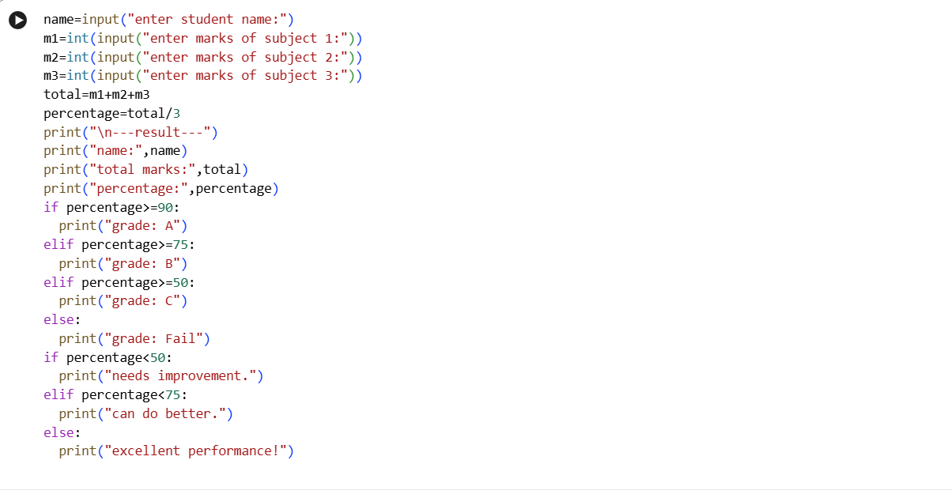
Output:
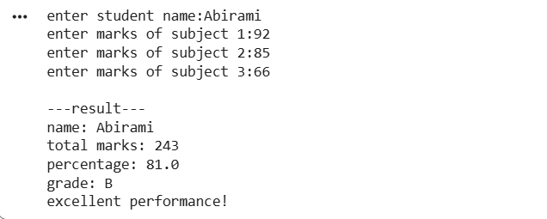
Due to screen size limitations, input and output are shown in two separate screenshots.

Tools Used
- Python programming language
- Google Colab

Challenges Faced
While doing this project, I initially found it difficult to understand how to use conditional statements properly. However, with practice, I was able to complete the program successfully.

Conclusion
This project helped me understand basic Python concepts such as input, calculations, and conditional statements. It also shows how Python can be used to solve simple real-life problems like evaluating student performance.

Screenshot Procedure
To capture the output, I ran the program in Google Colab and entered the inputs. Then I used the keyboard shortcut Windows + Shift + S to take a screenshot of the required area. The images were saved and inserted into this document.

